**DATA FLOW DIAGRAMS**

LEVEL 0 DFD FOR MATRIMONIAL PORTAL

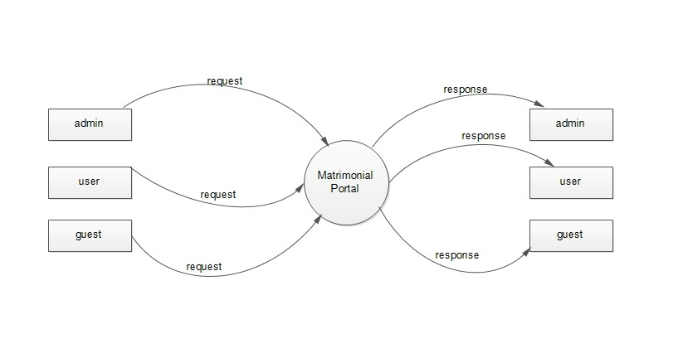

LEVEL 1 DFD FOR ADMIN

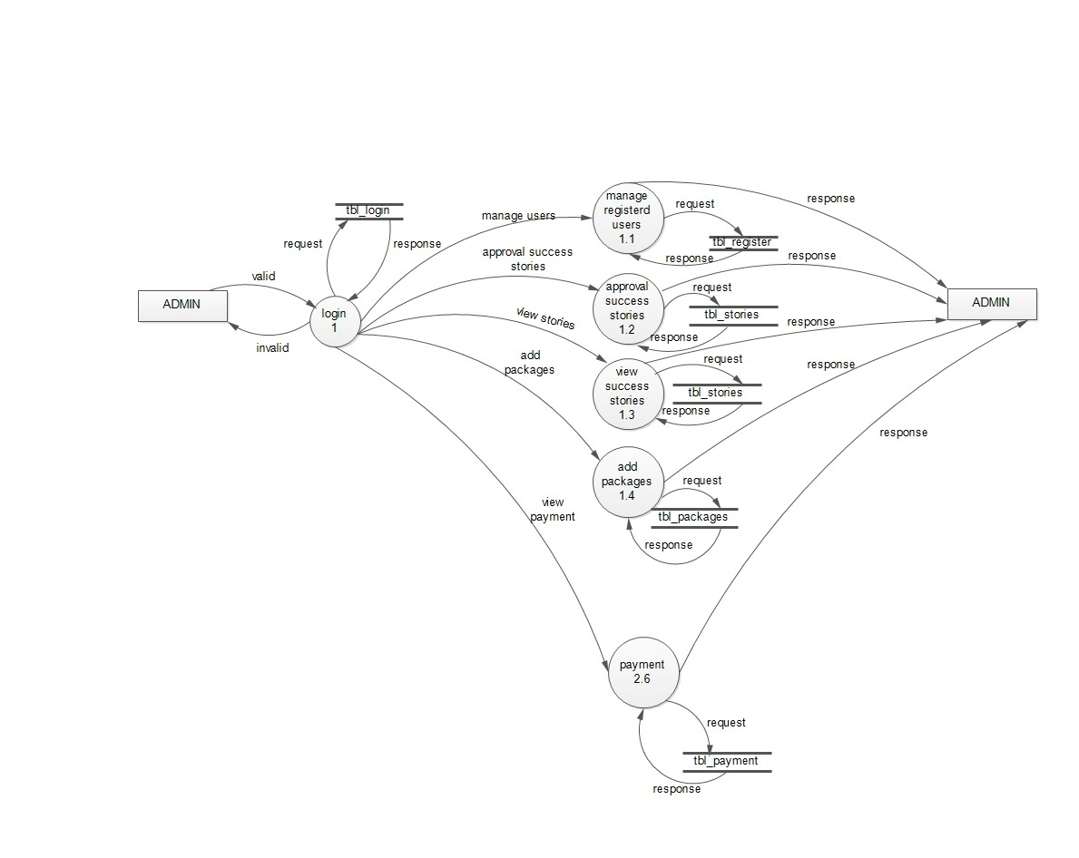

LEVEL 1 DFD FOR USER

